21BDS0340

Abhinav Dinesh Srivatsa

Microprocessors and Microcontrollers Lab

Task – III

**Question 1**

Aim:

Write an ALP 8051 program for timer 0 to generate a 200 Hz square wave frequency on P1.0. Examine the time using the KEIL IDE inbuilt Logic Analyzer

Tools Required:

8051 microcontroller

Keil microcontroller software

Program:

|  |  |  |  |
| --- | --- | --- | --- |
| Memory Locations | Label | Mnemonics | Comments |
|  |  | ORG 0000H |  |
| 0000H |  | MOV TMOD, #01H | Timer 0, mode 1 |
| 0003H | AGAIN: | MOV TH0, #0EEH | Setting time limit |
| 0006H |  | MOV TL0, #00H |  |
| 0009H |  | SETB TR0 | Start timer 0 |
| 000BH | LOOP: | JNB TF0, LOOP | Loop till timer 0 flag is 1 |
| 000EH |  | CLR TF0 | Clear timer 0 flag |
| 0010H |  | CLR TR0 | Clear timer 0 start |
| 0012H |  | CPL P1.0 | Complement P1.0 to create square wave |
| 0014H |  | SJMP AGAIN | Loop to AGAIN to repeat |
|  |  | END |  |

Manual Calculations:

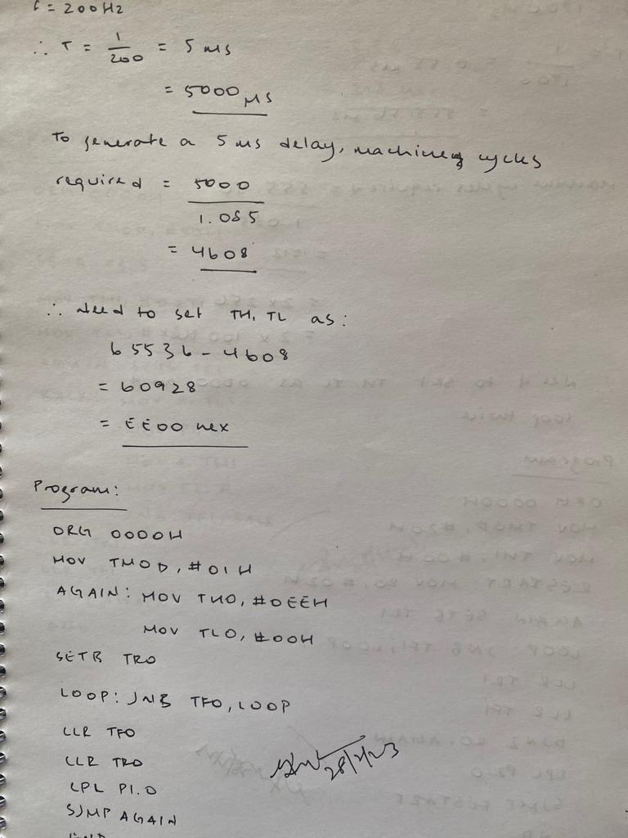

Output:

Result:

This program generates a square wave of frequency 200Hz on P1.0

**Question 2**

Aim:

Write an ALP 8051 program for timer 1 and 8-bit auto reload mode to generate a 1.8 kHz square wave frequency on P2.0. and examine the frequency using the KEIL IDE inbuilt Logic Analyzer

Tools Required:

8051 microcontroller

Keil microcontroller software

Program:

|  |  |  |  |
| --- | --- | --- | --- |
| Memory Locations | Label | Mnemonics | Comments |
|  |  | ORG 0000H |  |
| 0000H |  | MOV TMOD, #20H | Timer 1, mode 2 |
| 0003H |  | MOV TH1, #00H | Setting time limit |
| 0006H | RESTART: | MOV R0, #02H | Need to run timer twice |
| 0008H | AGAIN: | SETB TR1 | Start timer 1 |
| 000AH | LOOP: | JNB TF1, LOOP | Loop till timer1 flag is 1 |
| 000DH |  | CLR TR1 | Clear timer 1 start |
| 000FH |  | CLR TF1 | Clear timer 1 flag |
| 0011H |  | DJNZ R0, AGAIN | Decrement R0 and go to AGAIN if not zero |
| 0013H |  | CPL P2.0 | Complement P2.0 to create square wave |
| 0015H |  | SJMP RESTART | Loop to RESTART to repeat |
|  |  | END |  |

Manual Calculations:

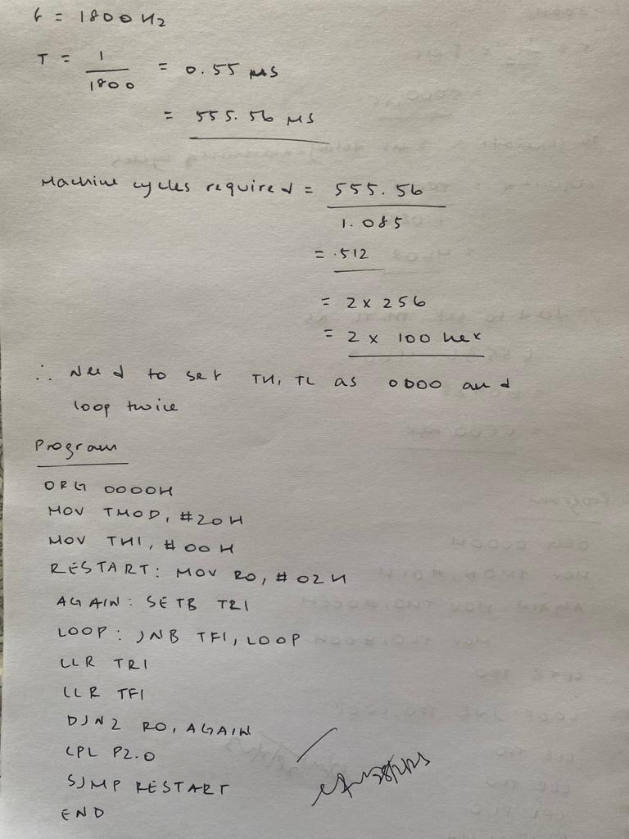

Output:

Result:

This program generates a square wave of frequency 1800Hz on P2.0

**Question 3**

Aim:

Write an ALP 8051 program for counter 1, mode1 and external pulse to count up to 65,000 and display the count on P2 and P1

Tools Required:

8051 microcontroller

Keil microcontroller software

Program:

|  |  |  |  |
| --- | --- | --- | --- |
| Memory Locations | Label | Mnemonics | Comments |
|  |  | ORG 0000H |  |
| 0000H |  | MOV TMOD, #50H | Counter 1, mode 1 |
| 0003H |  | SETB P3.5 | Setting P3.5 as input |
| 0005H |  | MOV TH1, #02H | Setting counter limit |
| 0008H |  | MOV TL1, #18H |  |
| 000BH | AGAIN: | SETB TR1 | Starting timer 1 |
| 000DH | BACK: | MOV A, TL1 | Moving LSB of counter to P1 |
| 000FH |  | MOV P1, A |  |
| 0011H |  | MOV A, TH1 | Moving MSB of counter to P1 |
| 0013H |  | MOV P2, A |  |
| 0015H |  | JNB TF1, BACK | Jump to BACK if timer flag 1 is not zero |
| 0018H |  | CLR TR1 | Clear timer 1 start |
| 001AH |  | CLR TF1 | Clear timer 1 flag |
| 001CH |  | SJMP AGAIN | Loop to AGAIN to repeat |
|  |  | END |  |

Manual Calculations:

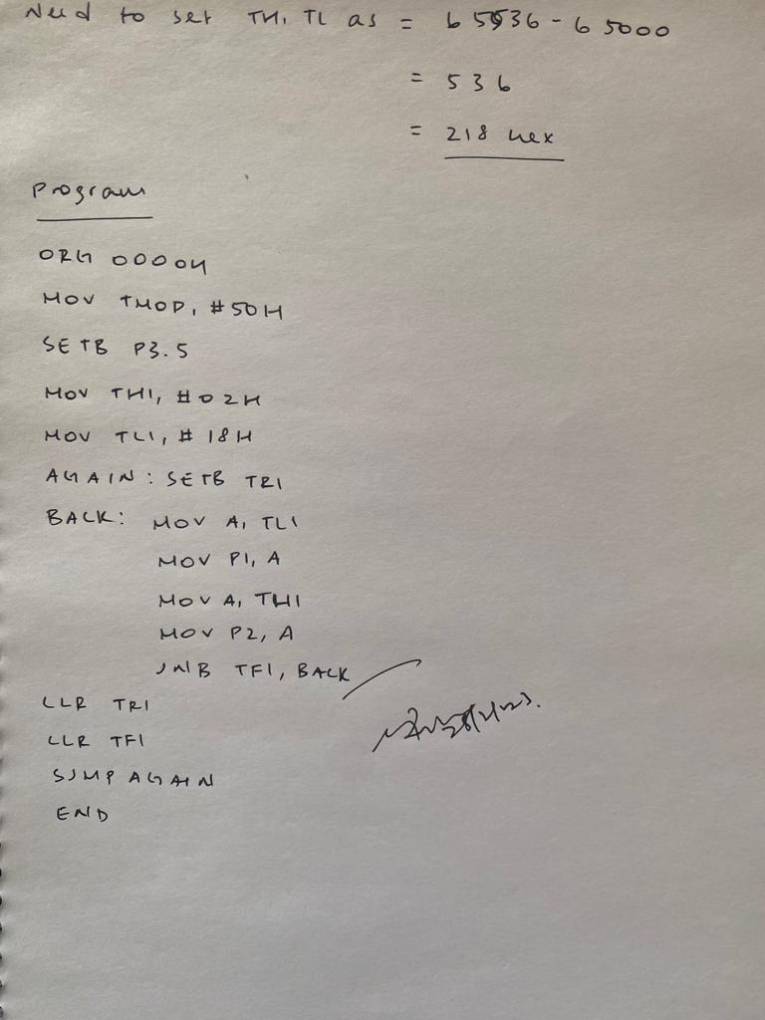

Output:

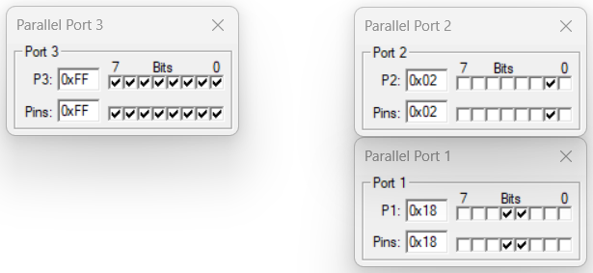

After a few toggles of P3.5

Result:

This program creates a counter that can count to 65000 by input on P3.5 and displaying the current count on P2 and P1